1.

**Continous Delivery** - Source, build, test, deploy artifact to Prod + Deploy manually to Prod is Continous delivery

**Continous Deployment** – There is no check point and deploy to production without any human intervention.

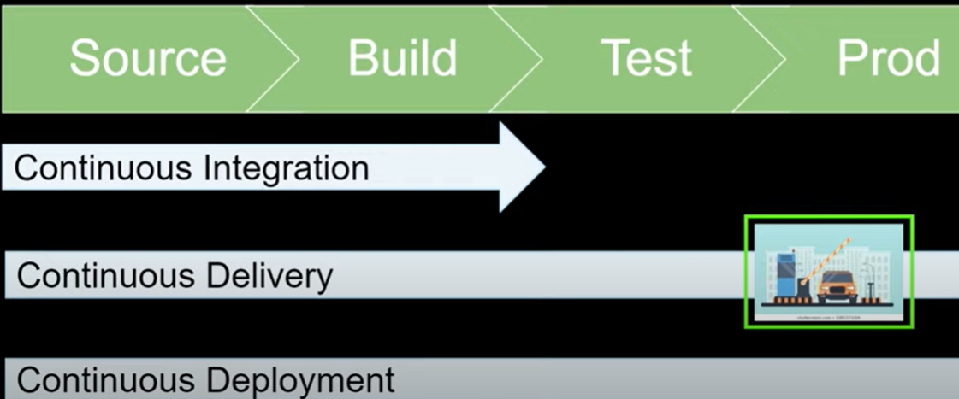

2. Devops Pipeline Implementation –

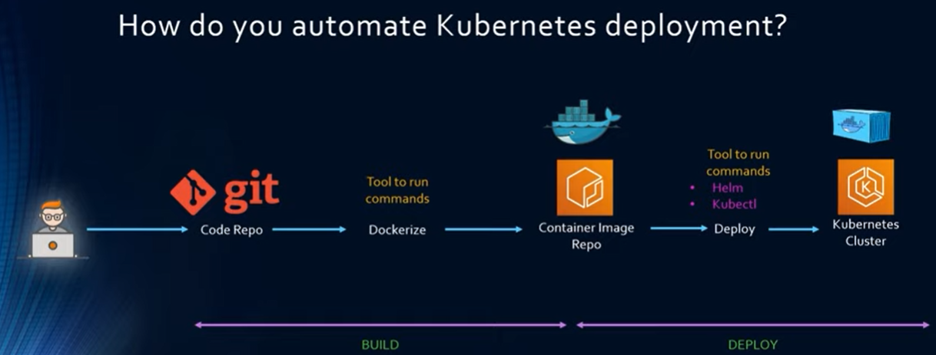

3. Challenges faced in the Devops Pipeline –

- Jenkins nodes/agents has multiple job could be slowness

- Need to pay for Jenkins EC2 on which Jenkins is running

Solution –

* Pay as you go
* Integrate with AWS services like Lambda

4. Unit testing framework to implement the unit testing

5. How to implement security in Devops

- Authorization (LDAP group of the application)

- Scan code for vulnerabilities(Veracode)

- Duplicacy(SonarQube)

- Security compliance(HIPPA, SOC etc.)